**Assignment-7**

**Login page:** First time you need to click register and second time you can use login button. this is first page



**Registration:** After clicking the register page you need to give all details as shown below and then click login. Thus your details will be added to Monogdb.

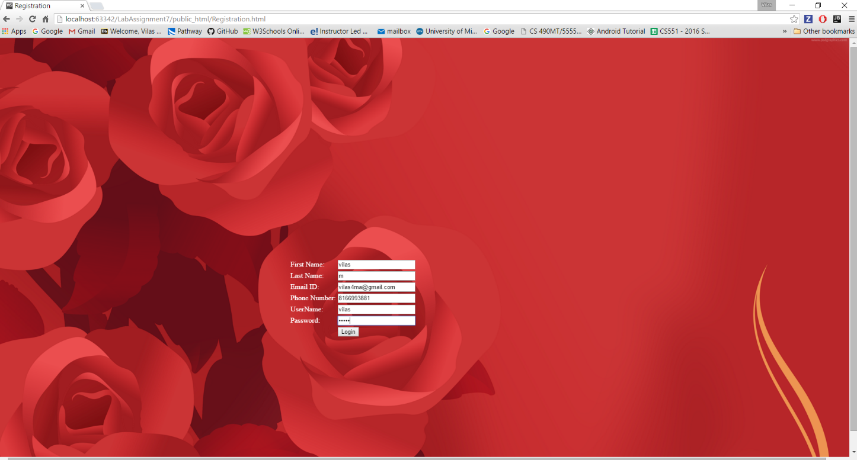

Database is created as below for the first time:

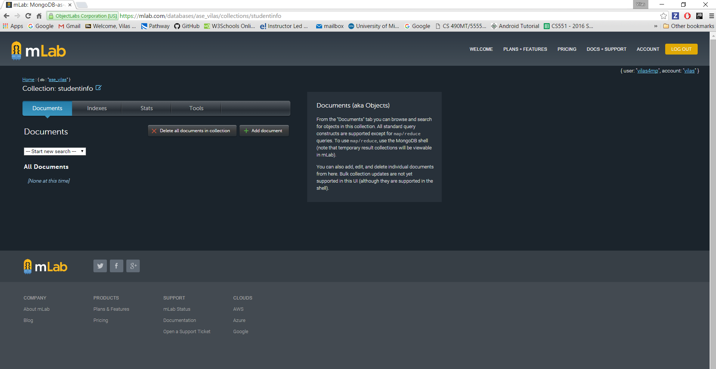

Once the user is registered the user will be prompted to the Login page and the record is inserted into the db.

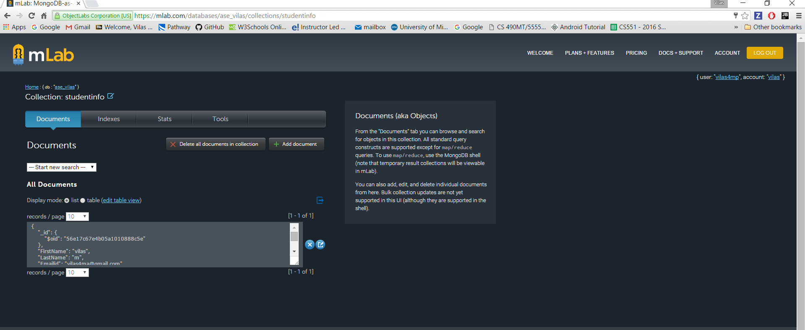

Now you can use your credentials to login .

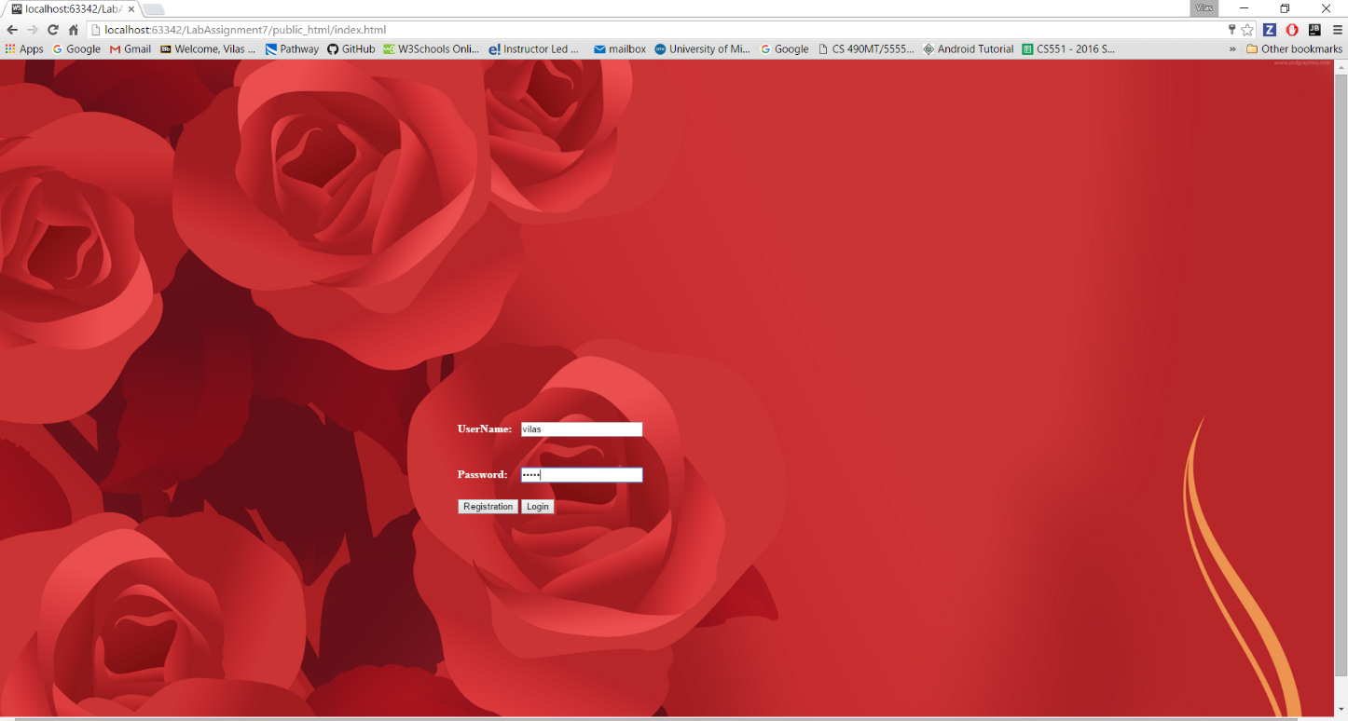

**Home Page:** this is home page which is height converter:

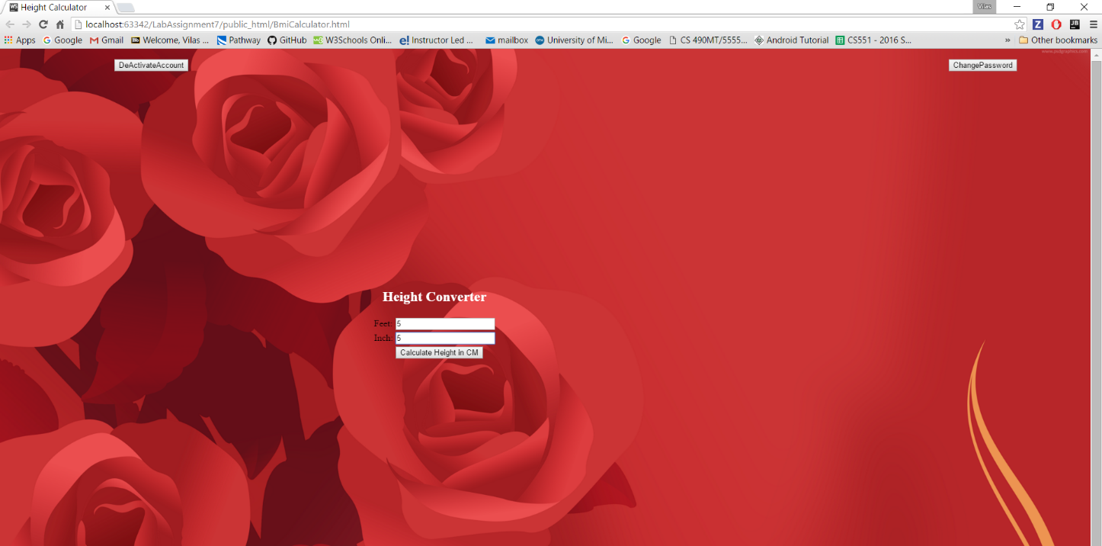

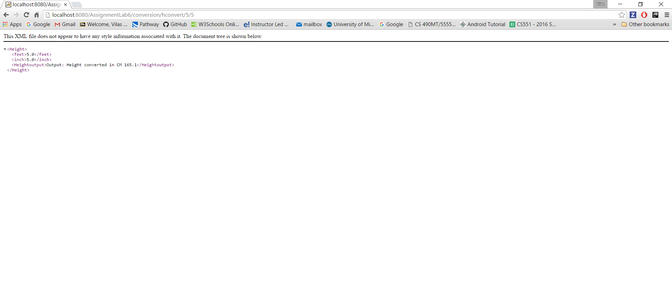

**Change Password:** You can change your password by clicking change password button and you will see the output as below:

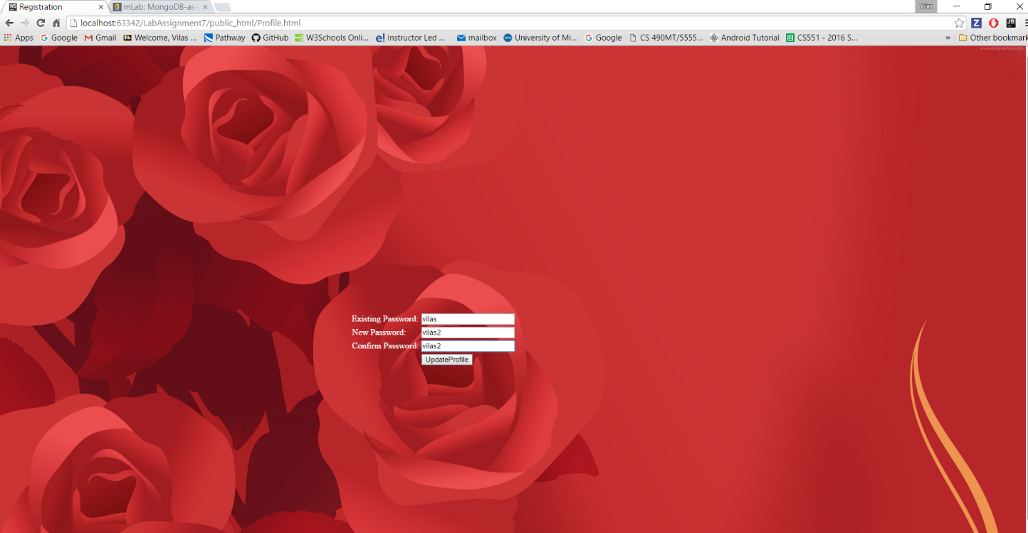

**Deactivate Account:** you can deactivate your account by clicking the deactivate button.you need to enter password to confirm the same.



Then you can see as below